HOW TO SETUP AND RUNNING SKY MAVIS API DEMO

1. Setup:

* Install Editor tool Intellij <https://www.jetbrains.com/idea/download/#section=mac>
* Install java environment
* Unzip file and open project by Intellij, maven will be automatically install dependencies

1. Running:
2. Preparation:

* Login google mail with account:

Email: [corn.bon.rain@gmail.com](mailto:corn.bon.rain@gmail.com)

Pass: zaqwsX12

* Delete all mail in the mailbox. In the future we will enhance this function to can work with multi email in mailbox

1. Per email just only uses one time so we will use an alias of gmail to configure. Go to data.properties file and change email before running(not change pass)

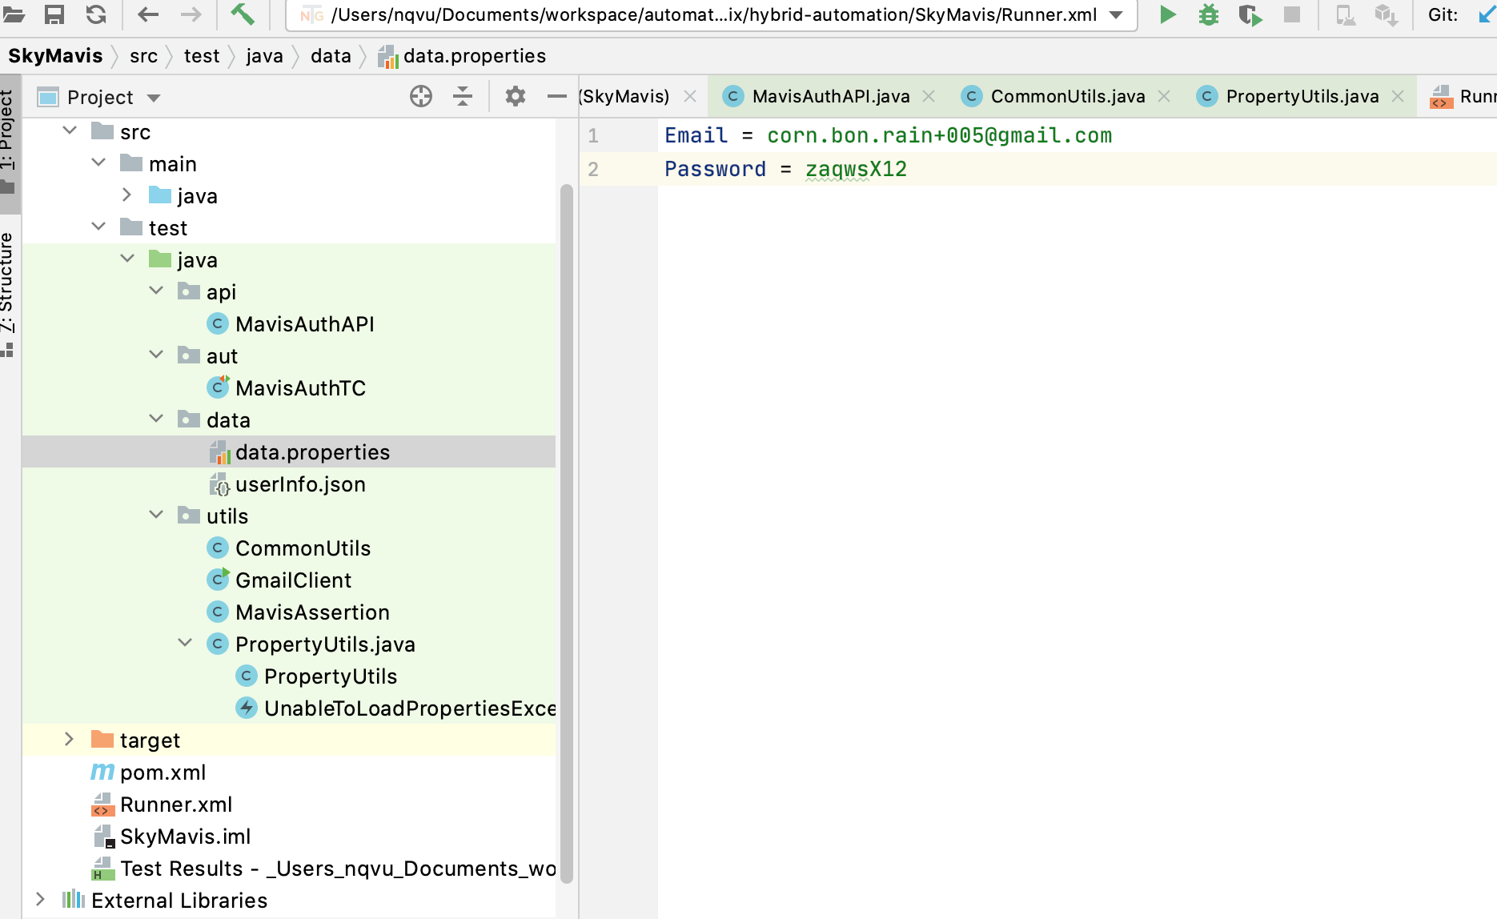

Example:

Change [corn.bon.rain@gmail.com](mailto:corn.bon.rain@gmail.com) to [corn.bon.rain+007@gmail.com](mailto:corn.bon.rain@gmail.com)

Note: just change the number.

1. Right click on Runner.xml and click run

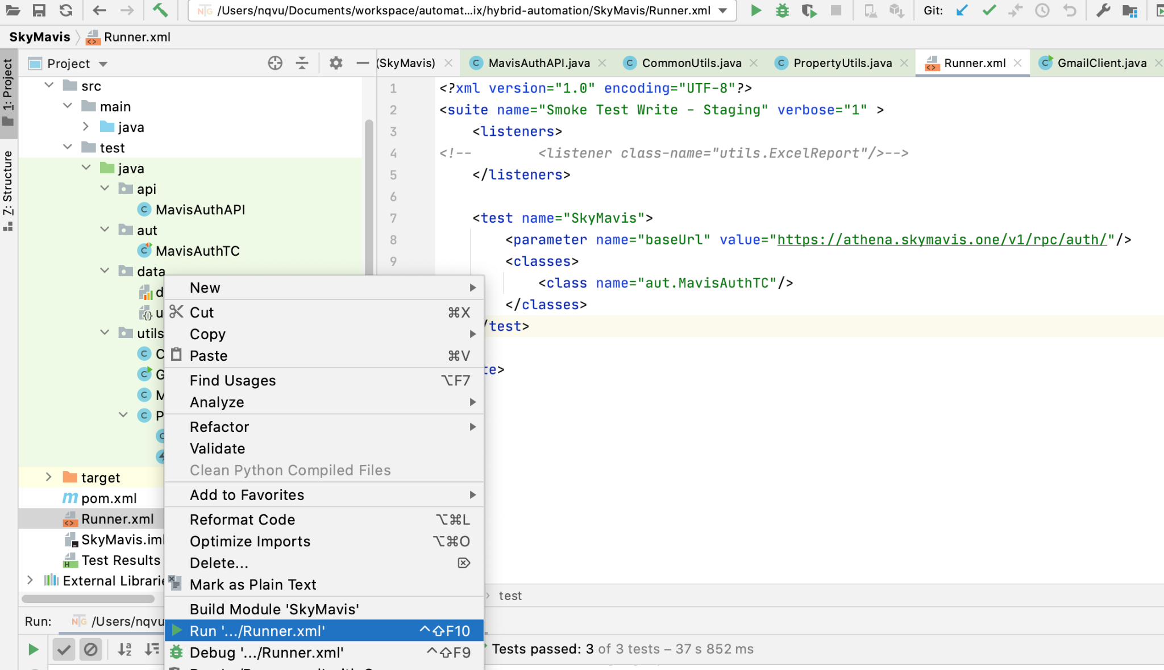

1. After suite done, user info will store at userInfo.json file

